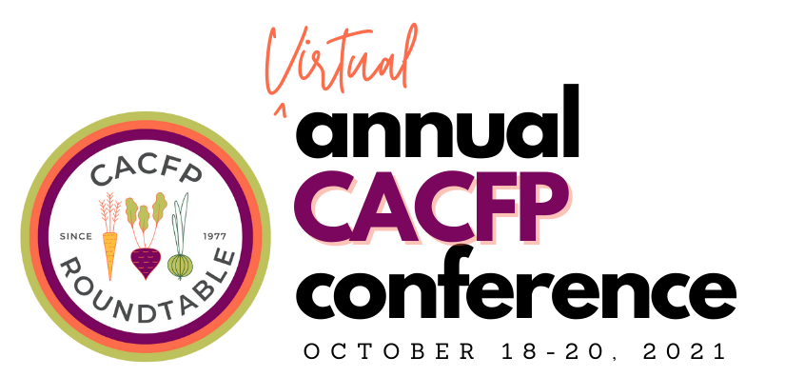

<Date>
Dear <Supervisor>:
The CACFP Roundtable’s Annual CACFP Conference, held virtually October 18-20, is a great opportunity to learn and connect with the CACFP community. This conference offers exceptional education, training and technical assistance, as well as networking opportunities to the Child and Adult Care Food Program (CACFP) community. This year the conference is completely virtual and focused on supporting the CACFP community with the most current and relevant issues and challenges.
This will be a three-day professional education event with 20+ interactive workshop sessions that will cover topics related to CACFP and pandemic recovery; policy and advocacy; racial and social justice; and leadership development.
The CACFP Roundtable is providing attendees with a top shelf virtual conference platform, which will ensure opportunities for networking with local, regional, and national CACFP peers and leaders. Participation in this conference will provide me with new knowledge, skills, and resources to ensure our organization continues to be successful in operating the CACFP.
This is an important event for CACFP professionals and is the premier education event for our community. I believe by attending the CACFP Roundtable’s Annual CACFP Conference, I will further my professional development and bring back new ideas to our team. The conference will also offer an opportunity for me to hear directly from USDA officials and to discuss relevant updates and challenges the CACFP faces.
I seek approval for the registration fee only, as no travel or lodging will be necessary. The conference registration fee is <find your fee at this link and fill it in here>.
Thank you in advance for the opportunity to gain valuable knowledge from industry experts and network with the CACFP community. I look forward to coming back to <name of your organization> and sharing all that I learned at the CACFP Roundtable’s Annual CACFP Conference 2021.
Sincerely,
<Your Name>

