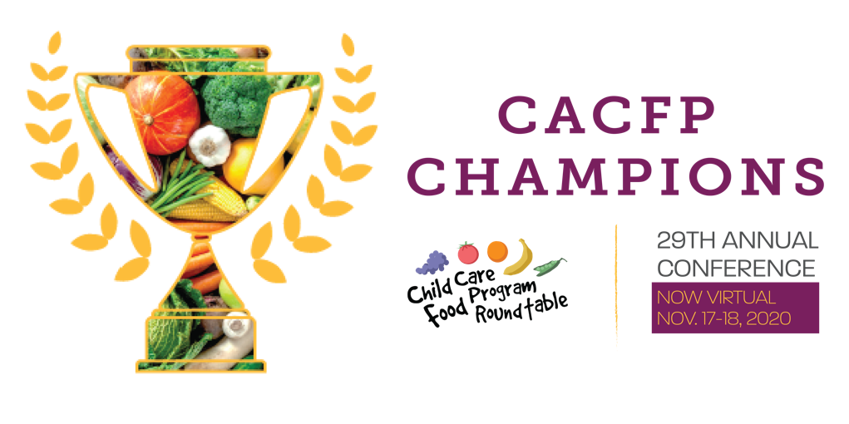

<Date>
Dear <Supervisor>:
The 2020 CCFP Roundtable Virtual Annual Conference, held November 17-18, is a great opportunity to learn and connect with the CACFP community. This conference offers exceptional education, training and technical assistance, as well as networking opportunities to the Child and Adult Care Food Program (CACFP) community. This year the conference is completely virtual and focused on supporting the CACFP community with the most current and relevant issues and challenges.
This will be a two-day professional education event with 20 workshop sessions that will cover topics related to surviving COVID-19/disasters; meal service during COVID-19; non-congregate feeding/bulk meal service; equity and anti-racism in the CACFP; overall program operations; program administration; civil rights; and nutrition education.
Even virtually, the conference is an opportunity for networking with local, regional, and national peers and leaders, and for increasing knowledge and identifying and utilizing available resources. In total, participation in this conference will provide me with additional knowledge and resources to ensure our organization continues to be successful in operating the CACFP.
This is an important event for CACFP professionals and is the premier event for our community. I believe by attending the Roundtable’s Annual Conference, I will further my professional development and bring back new ideas to our agency and team. The conference will also offer an opportunity for me to hear from USDA officials and to discuss relevant updates and challenges the program faces.
I seek approval for the registration fee only, as no travel or lodging will be necessary. The conference registration fee is <find your fee at this link and fill it in here>.
Thank you in advance for the opportunity to gain valuable knowledge from industry experts and network with other CACFP professionals. I look forward to coming back to <name of your organization> and sharing all that I learned at the Roundtable’s Virtual Annual Conference 2020. Additional information about the conference can be found at https://www.ccfproundtable.org/2020conference.
Sincerely,
<Your Name>

